2020380029

**HOME WORK**

**#2.3,2.4,2.5,2.6**

RAIHAN MD RAKIBUL ISLAM

**#2.3**

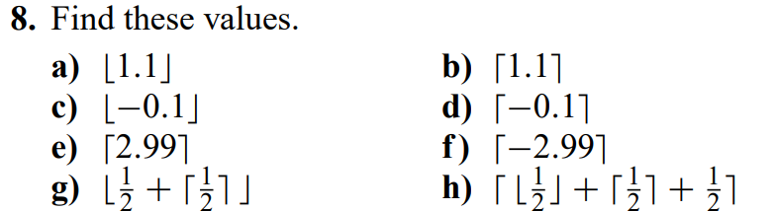

1. 1
2. 2
3. -1
4. 0
5. 3
6. -2
7. 1
8. 2

20. Give an example of a function from N to N that is

a) one-to-one but not onto.

**f(n) =**

b) onto but not one-to-one.

**f(n)= ⌈n/2⌉**

c) both onto and one-to-one (but different from the identity function).

**f(n) =**

d) neither one-to-one nor onto.

**f(n) = 0**

24. Let f: R → R and let f (x) > 0 for all x ∈ R. Show that f (x) is strictly increasing if and only if the function g(x) = 1/f (x) is strictly decreasing.

**Open for proof that f(x) is strictly increasing if and only if g(x) = is strictly decreasing**

33. Suppose that g is a function from A to B and f is a function from B to C.

a) Show that if both f and g are one-to-one functions, then f ◦ g is also one-to-one.

Solution:

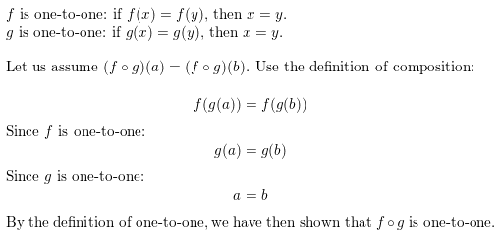

b) Show that if both f and g are onto functions, then f ◦ g is also onto.

Solution:

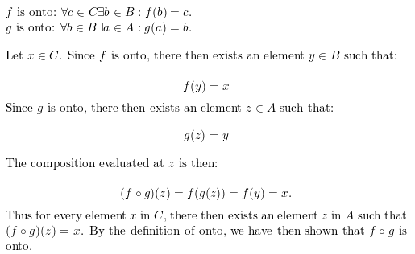

64. Draw the graph of the function f (x) = L x/2⌋ from R to R.

**Evaluate the functions at few values and plot the corresponding points on a set of axis. Then draw roughly the curve through these points.**

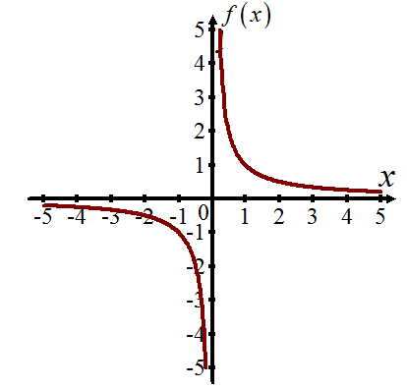

**#2.4**

26. For each of these lists of integers, provide a simple formula or rule that generates the terms of an integer sequence that begins with the given list. Assuming that your formula or rule is correct, determine the next three terms of the sequence.

a) 3, 6, 11, 18, 27, 38, 51, 66, 83, 102, ...

123,146,171

b) 7, 11, 15, 19, 23, 27, 31, 35, 39, 43, ...

47,51,55

c) 1, 10, 11, 100, 101, 110, 111, 1000, 1001, 1010, 1011, ...

1100,1101,1110

d) 1, 2, 2, 2, 3, 3, 3, 3, 3, 5, 5, 5, 5, 5, 5, 5, ...

8,8,8

e) 0, 2, 8, 26, 80, 242, 728, 2186, 6560, 19682, ...

59048,177146,531440

f) 1, 3, 15, 105, 945, 10395, 135135, 2027025,34459425, ...

654729075,13749310575,316234143225

g) 1, 0, 0, 1, 1, 1, 0, 0, 0, 0, 1, 1, 1, 1, 1, ...

0,0,0

h) 2, 4, 16, 256, 65536, 4294967296, ...

18446744073709551616,

340282366920938463374607431211456,

1157920892373161954235709850086879078536998466564056403945758400791312963993

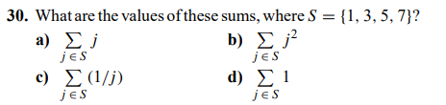

a) 16

b) 84

c)

d) 4

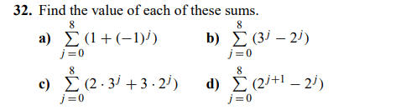

a) 21

b) 78

c) 18

d) 18

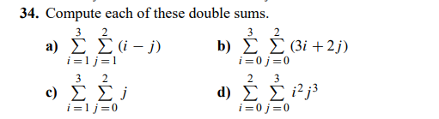

a) 3

b) 78

c) 9

d) 180

**#2.5**

2. Determine whether each of these sets is finite, countably infinite, or uncountable. For those that are countably infinite, exhibit a one-to-one correspondence between the set of positive integers and that set.

a) the integers greater than 10

countably infinite

b) the odd negative integers

countably infinite

c) the integers with absolute value less than 1,000,000

finite

d) the real numbers between 0 and 2

uncountable

e) the set A × Z+ where A = {2, 3}

countably finite

f) the integers that are multiples of 1

countably finite

10. Give an example of two uncountable sets A and B such that A − B is

a) finite.

A — B = R — (R — (0)) = (0).

Since the set {0) contains only 1 element, the set (0) is finite and thus A —B is finite as well.

b) countably infinite.

A — B ((0, 1) UN) — (0, 1) =N. The set N of nonnegative integers is countable infinite

c) uncountable.

A — B =R — (R- U {O}) = The set R+ of positive real numbers is uncountable.

**#2.6**

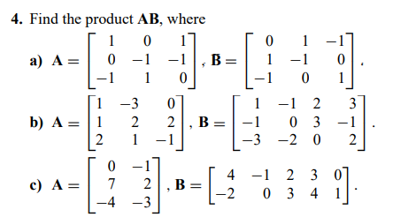

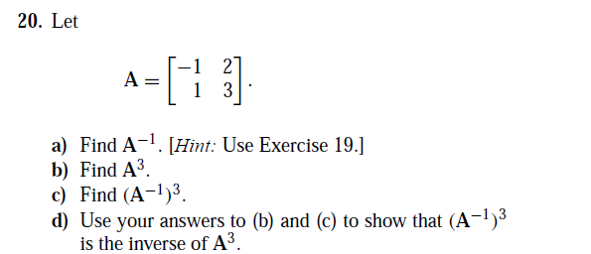

1. Given, A=
2. By the previous exercise, we know that the inverse A= is =

In this case, a = -1, b = 2, c = 1 and d = 3

is the product of

=

is the product of

1. From part a

= =

===

By part (b):

In this case, a = 1, b = 18, c = 9 and d = 37

=

We now note that

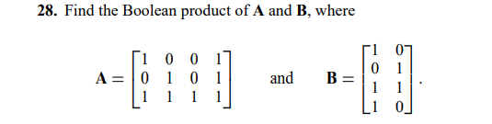

Solution: A * B =*

=

=

=

**32.** In this exercise we show that the meet and join operations are associative. Let **A**, **B**, and **C** be *m* × *n* zero–one matrix. Show that

**a)** *(***A** ∨ **B***)* ∨ **C** = **A** ∨ *(***B** ∨ **C***)*.

Solution:

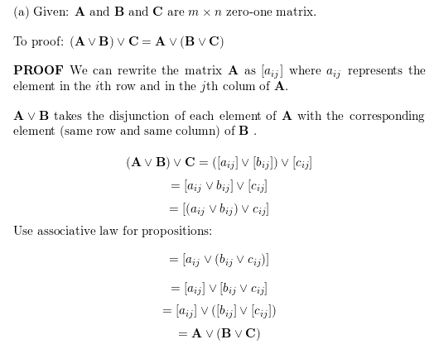

**b)** *(***A** ∧ **B***)* ∧ **C** = **A** ∧ *(***B** ∧ **C***)*.

Solution:

